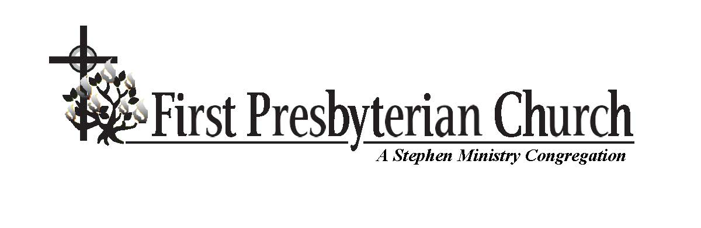 December 24, 2018 7:00 p.m.
Christmas Eve Service
The mission of First Presbyterian Church of St. Petersburg is to be and make disciples of Jesus Christ, who know God and, through love, serve the Lord and others. We will accomplish our mission by practicing radical hospitality, passionate worship, intentional faith development, risk-taking mission, and extravagant generosity.
preparation
*Please stand, if able. Responses are in boldface.
(Please use the prelude as a time for reflection and preparation for worship.)
PRELUDE
“Ding Dong Merrily on High” arr. Dana F. Everson
“Interlude on Stille Nacht" (Silent Night) Alan Bullard (b. 1947)
“Still, Still, Still” arr. Thomas H. Graf
Brass quartet; Jack Rain, piano/organ
WELCOME AND ANNOUNCEMENTS
ADORATION AND PRAISE
Call to Worship
Let the heavens be glad, and the earth rejoice.
The grace of God has come to save us.
For our sakes, God sent the child of Bethlehem.
For our salvation, Jesus came to live among us.
Let all people sing for joy and give thanks.
Tell the world what God has done in our midst.
God has called and chosen us to hear the good news.
God’s marvelous works are new every morning.
Glory to God in the highest.
Peace on earth to all who please God.
We seek to honor God in this time of worship.
We want to see for ourselves what God has done.
*PROCESSIONAL HYMN 133 “O Come, All Ye Faithful” ADESTE FIDELES
LIGHTING OF THE CHRIST CANDLE
Robert Johnson–Isaiah, Uneeda Brewer–Elizabeth, Joe Emerson–Shepherd,
Karen Kisten–Innkeeper's Wife
PRAYER
PRAYER OF CONFESSION
God of the commonplace, we confess that we have been impressed by power and authority. We do not expect to meet you in the poor of the land, in cold barns, or on lonely duty watches. We are slow to hear the angels or to embrace the “good news of great joy.” We hesitate to leave our chosen tasks to share in your larger purposes. We settle for idols of material security even as you thrust us into the battles of life, where we have nothing on which to rely other than our faith in you. Forgive our lack of trust. Renew us in the Holy Spirit, we pray. Amen.
ASSURANCE OF FORGIVENESS
The grace of God has appeared for the salvation of all. Do not be afraid. This is a day for good news of great joy. The Savior is born anew in our midst. Glory to God in the highest! Praise God for all we are seeing and hearing, as love is made known among us.
*pASSING OF THE PEACE Robin Lyle, Elder
The peace of our Lord Jesus Christ be with you all.
And also with you.
Please exchange signs of reconciliation and peace with those sitting around you.
PROCLAMATION
CHILDREN’S MESSAGE Barbara Brownlee
*HYMN OF RESPONSE 147 “The First Nowell” THE FIRST NOWELL
arr. Dan Forrest
Congregation sings vv. 1 & 6 with choir and brass quartet
SCRIPTURE READINGS
First Lesson: Isaiah 9:2-7 Robin Lyle, Elder
(pew Bible, Old Testament, page 780)
Second Lesson: Luke 2:1-20 Dr. Dawn Conti
(pew Bible, New Testament, page 71)
This is the Word of the Lord.
Thanks be to God!
SERMON “The Best Gift Ever Given” Dr. Dawn Conti
RESPONSE
PRESENTING OUR GIFTS
OFFERTORY “O Holy Night” Adolphe Adam
(1803-1856)
arr. Stephen DeCesare
Brass quartet and organ
PRAYER OF DEDICATION
THE CANDLELIGHT SERVICE
CANDLELIGHTING
The congregation will stand (as able) and remain standing until the service concludes. The pastor will light her candle from the Christ candle and then light those of the candle lighters. They will then proceed down the aisles, lighting the candle of the person at the end of each row. When your candle is lit, please pass the light to the person next to you. This treasured ritual symbolizes the light of Christ moving from the announcement of the Word (John 1:1-5) and spreading throughout the world.
*HYMN 122 “Silent Night, Holy Night!” Stille nacht
Silent night, holy night! All is calm, all is bright, round yon virgin mother and child! Holy Infant, so tender and mild, sleep in heavenly peace, sleep in heavenly peace.
Silent night, holy night! Shepherds quake at the sight. Glories stream from heaven afar, heavenly hosts sing: “Alleluia! Christ the Savior is born; Christ the Savior is born.”
Silent night, holy night! Son of God, love’s pure light. Radiant beams from thy holy face, with the dawn of redeeming grace, Jesus, Lord, at thy birth, Jesus, Lord, at thy birth.
Silent night, holy night! Wondrous star, lend thy light; with the angels let us sing Alleluia to our King; Christ the Savior is born, Christ the Savior is born.
*THE LORD’S PRAYER (sung by the congregation)
Our Father which art in heaven, hallowed be thy name. Thy kingdom come, thy will be done, on earth as it is in heaven. Give us this day our daily bread; and forgive us our debts as we forgive our debtors; and lead us not into temptation, but deliver us from evil. For thine is the kingdom and the power and the glory, forever. Amen. (Please extinguish your candle.)
*HYMN 119 “Hark! The Herald Angels Sing” MENDELSSOHN
A concertato setting by Walter L. Pelz
Congregation sings vv. 1 & 3 with choir and brass quartet
*BENEDICTION
POSTLUDE
“Toccata on Adeste Fideles” Sandra K. Tucker
(b. 1957)

